Time Series Forecasting Project - Australian Gas Production

Submitted by
Renjith Mohan K
07/26/2020

1 Project Objective
The objective of the project is to explore the Australian monthly gas production dataset and to forecast the production for a period of 12 months. The data set -gas is downloaded from the forecast package available in R. As a part of it, we will be performing the below activities -

1. Read the data as a time series object in R. Plot the data
2. Observations from the above as which components of the time series are present in this dataset?
3. What is the periodicity of data set?
4. Is the time series Stationary? Inspect visually as well as conduct an ADF test? Write down the null and alternate hypothesis for the stationarity test? De-seasonalise the series if seasonality is present?
5. Develop an ARIMA Model to forecast for next 12 periods. Use both manual and auto.arima (Show & explain all the steps)
6. Report the accuracy of the model

Assumptions
NA

Exploratory Data Analysis – Step by step approach

Environment Set up and Data Import
Install necessary Packages and Invoke Libraries
As a part of this problem, we installed the ncessary packages and afterwards loaded into library with the aid of library() function. These include the below -
library('ggplot2')
library('forecast')
library('tseries')
library('MLmetrics')
Library(‘stats’)

Please refer Appendix A for Source Code

Set up working Directory
We will be reading the data directly from R’s forecast package - forecast::gas. We use the below
Please refer Appendix A for Source Code

1.Read the data as a time series object in R. Plot the data
The given dataset is from the forecast package is already a time series object. We read it by using the below function

Please refer Appendix A for Source Code.

EDA - Basic data summary, Seasonplot, MonthPlot graphs

Approach: For basic data summary /variable identification, we use the R functions - class,str, summary, head, tail. The purpose of each of the functions are briefly mentioned below -

class - we use this to get the type of data set
str - we use this to get the structure of the variable/column names like factor, integer or numeric.
summary - we use this to get a summary of the column names. It gives us the 5 point summary with details of min, max. Median, 25th percentile & 75th percentile.Basically we perform descriptive statistic with this one.
head - we use this to check a sample of data from the data frame. By default it gives the first 6 records.
tail - we use this also to check sample records from the data frame. By default it gives the last 6 records.
frequency - we use this to check the periodicity of the time series.

Please refer Appendix A for Source Code.

EDA - Basic data Inference

Below are the inferences from the above EDA step -

We see that the data set is aready a times eriesby using the class() function. We also verified that the data series starts from 1956-Jan and extends till 1995-August using the from “str” and head/tail command, . From Summary, we observed tha the volume ranges b/w 1646 and 66600

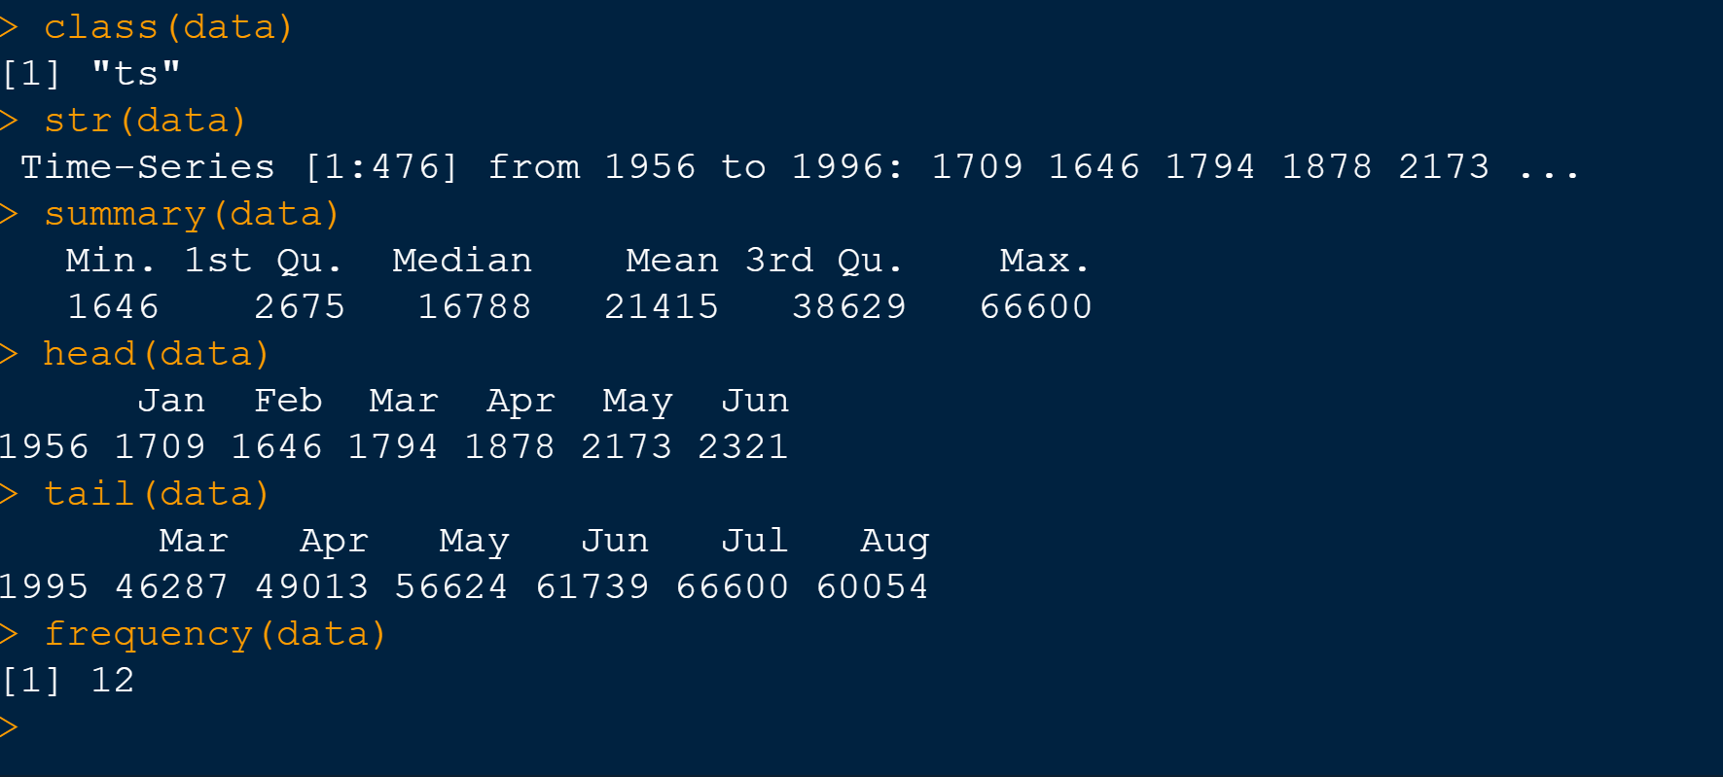

Please refer Appendix A for Source Code.

Missing Value Treatment
From ayNA() function, we identified that there is NO missing values for the gas data set.

Outlier Treatment

NA

3.2.2 EDA

Approach: Use Plots, MonthPlots,SeasonPlots and Boxplots

Analysis-autoplot

Observations: We see that the dataset has varying trend from its visual observations. Also it looks like having some kind of seasonality. Since there is no change in data till 1970, we will create a new dataset with start date as 1970-Jan and end as 1995-Aug

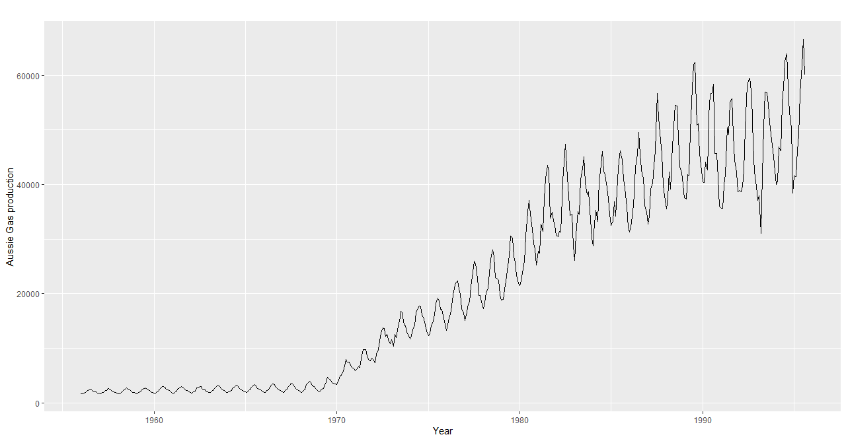
Modified Dataset:

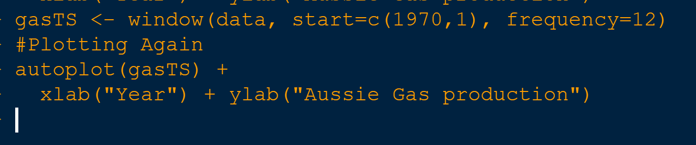

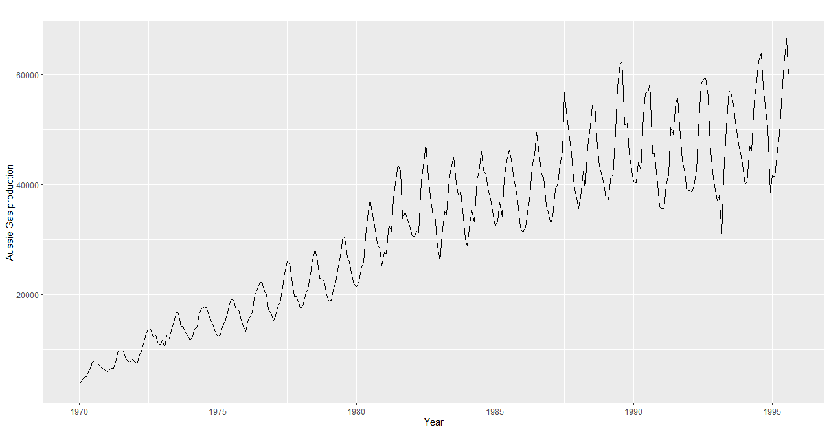

Analysis- Monthplot

Observations: From the month plot, we see that there is a recurring pattern in Seasonality.We see that the volume increases from Jan to July and then decreases for the next 6 months till Dec.

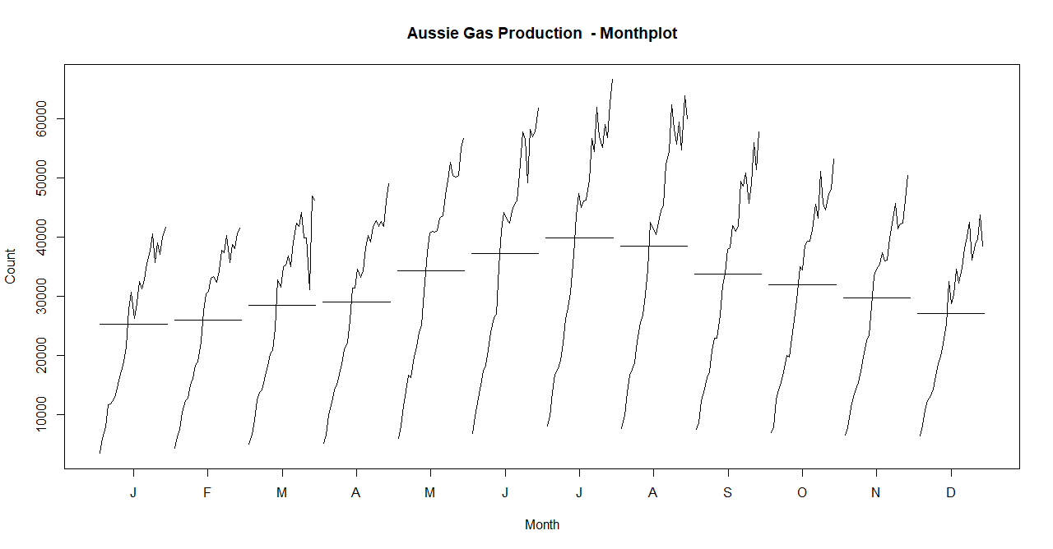

Analysis- Season Plot
Observations: From the Season plot, we see that over a period of time, there has been a regular increase in volume which affirms the fact that our data set has an increasing trend for the data starting from 1970.

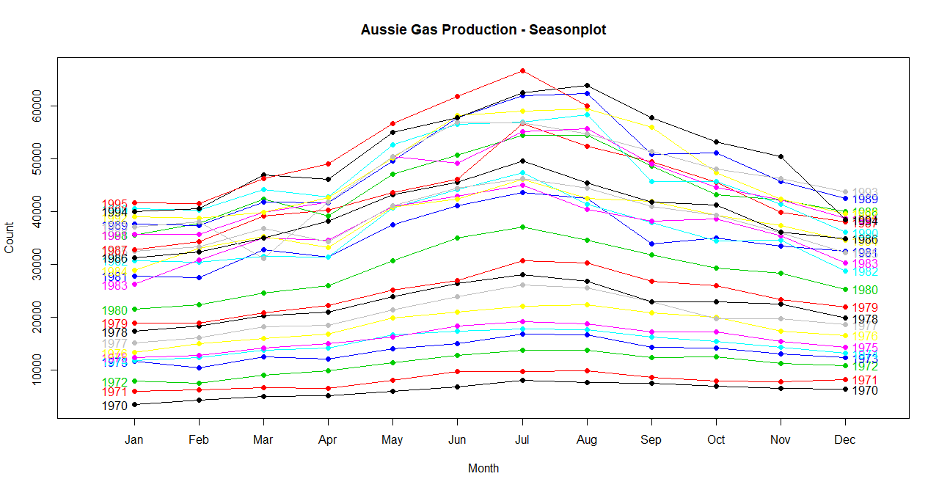

Analysis- Box Plot
Observations: From the boxplot we see the same behavior as it was for the month plot. The peak volumes are observed for July and the lease volumes were observed for Jan & Dec months.

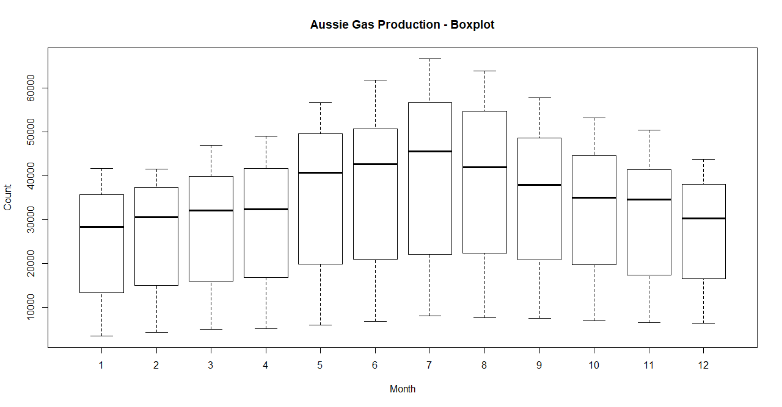

Observations from the above as which components of the time series are present in this dataset?

From the above plots, we see that the below components are present in the data set
- Level
- Trend ( Increasing)
- Seasonality( Looks to be Additive from Visual representation)

What is the periodicity of data set?

Periodicity means how often the observations of a time series occur for the given data set.We can use the frequency command to find out what is the periodicity of a time series. Our “gas” dataset has one observation for a month (frequency = 12) and so it has a monthly periodicity or can be called as a monthly time series.

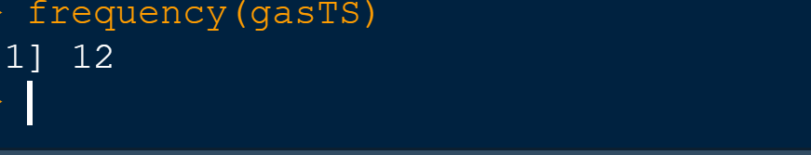

Checking for Seasonality and de-seasonalization

Lets use the decompose & stl commands to check for seasonal component in the data set.We will check for both Additive and Multiplicative seasonalities.

Observations: We see that the sesaonal effect is negligible when we do a multiplicative seasonality. But the effects are quite dominant for the additive graphs. So we can confirm that our series has an additive seasonality

So we will go ahead and use stl() with s,window=”p” meant for constant seasonality, so that we can get the components separated

Finally as a part of de-seasonalizing, we will add up the trend and remainder component and ignore seasonality from the dataset.

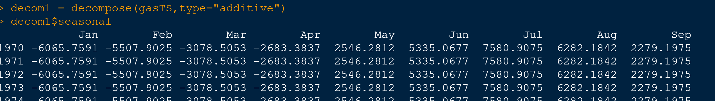

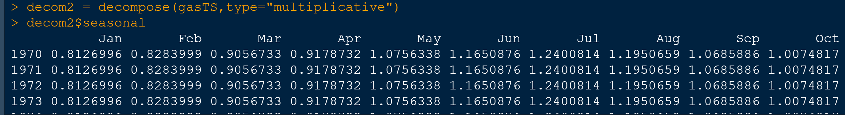

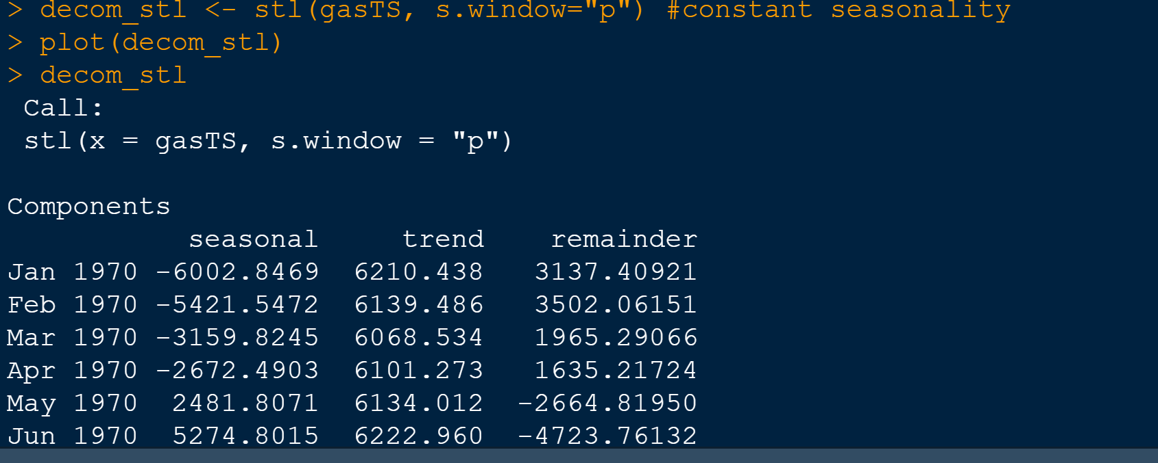

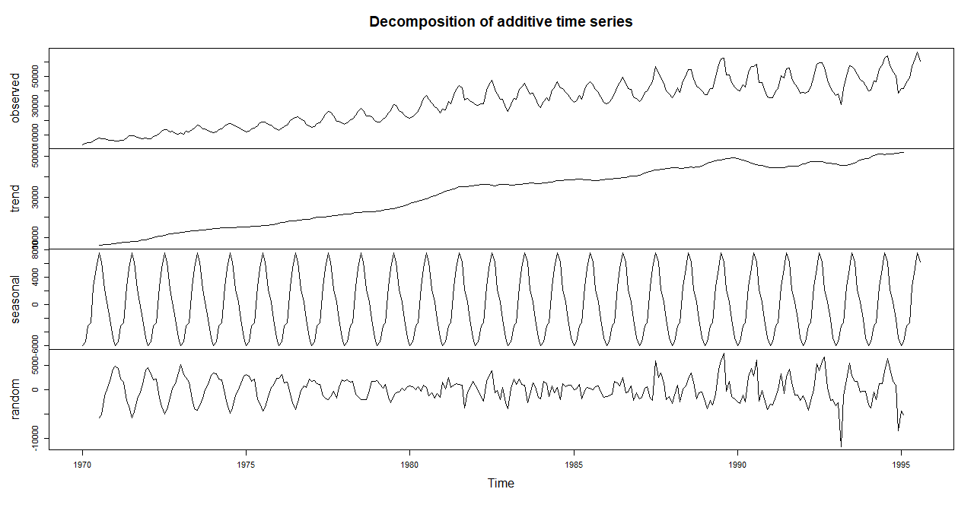

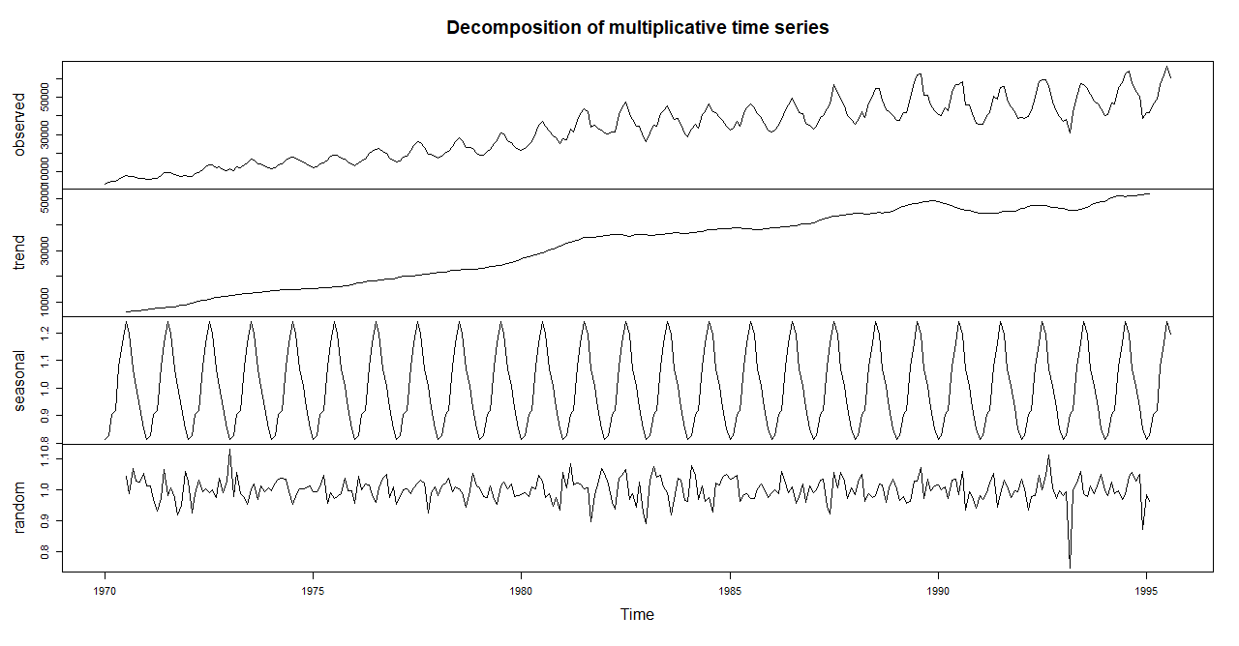
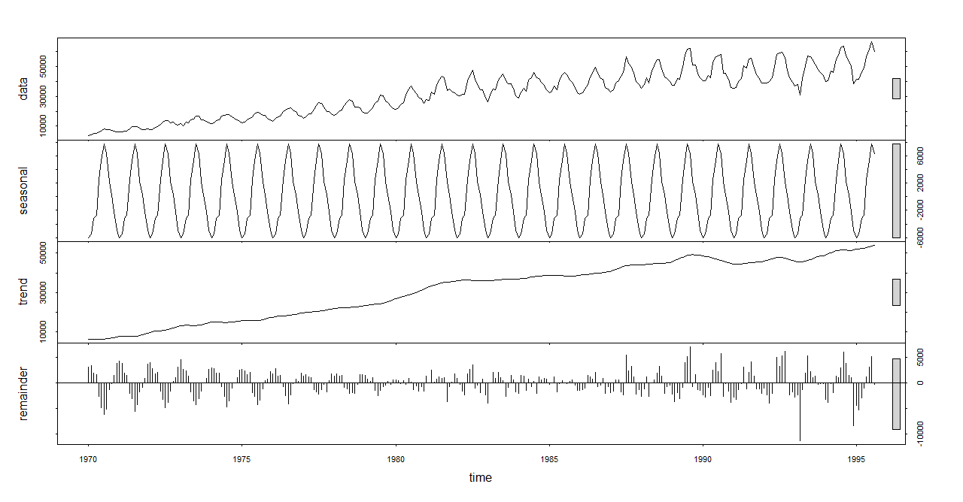
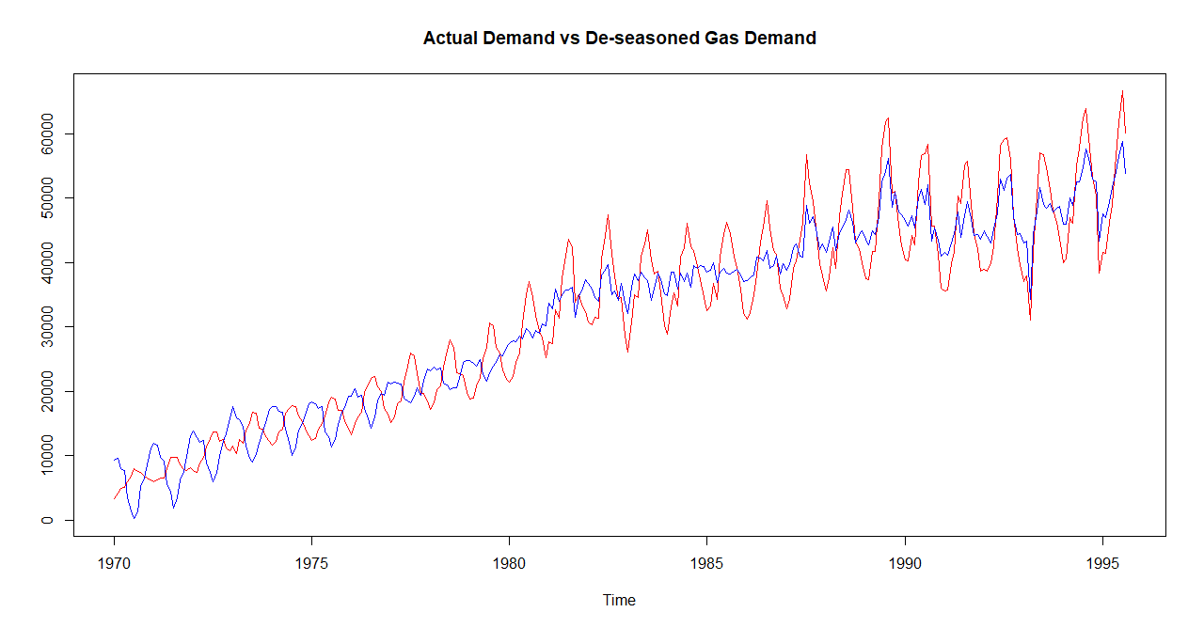

Partitioning the data set into train and test

Now we will partition the data set into train and test. For this purpose, we will consider the data from 1970-Jan to 1993-Dec as the train data set and the remaining data - from 1994-Jan to 1995-August as test.

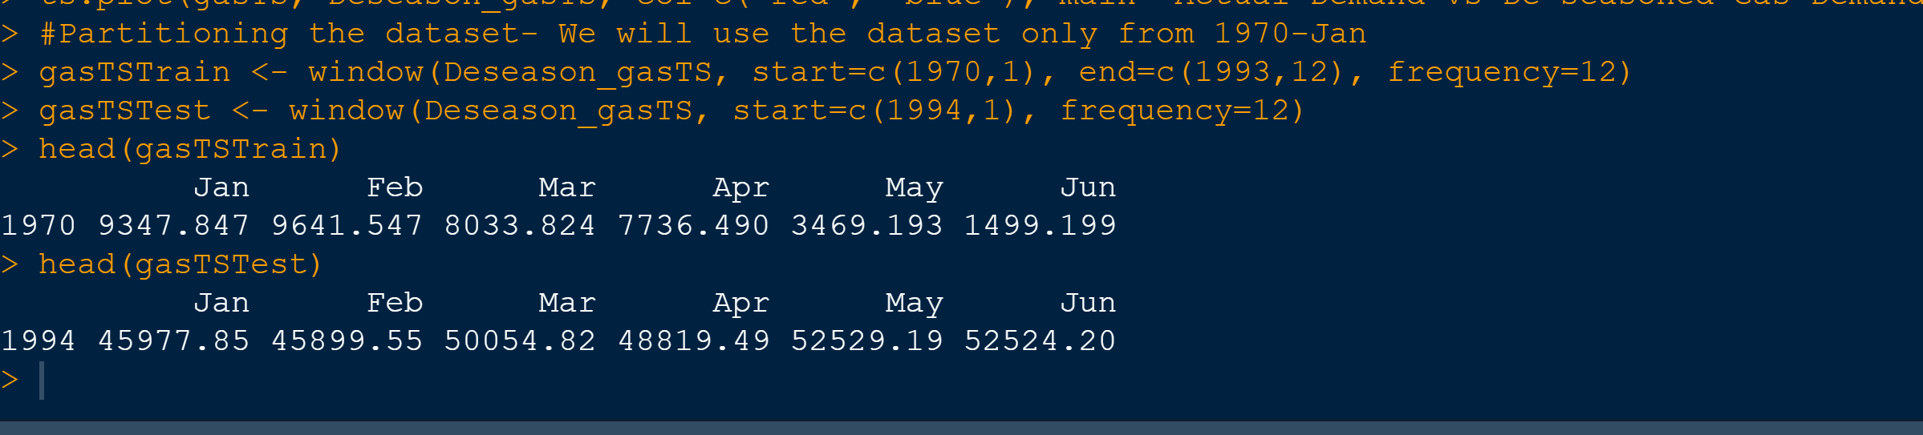

Is the time series Stationary? Inspect visually as well as conduct an ADF test?

We will use the Augmented Dickey Fuller test to check on the Stationarity of the time series. We will use this test on the entire dataset ( from 1970) as well on the train dataset. Since we are using the train series to build the dataset, we will proceed with the outcome on that. We will also perform it on the test data just to see the outcome. Finally we will also do a ndiffs() to find the optimum no: of differencing , perform it and confirm if the new series is stationary.

ADF : Dickey–Fuller test tests the null hypothesis that a unit root is present in an autoregressive model. The alternative hypothesis is usually stationarity or trend-stationarity

H0: Series is not stationary
Ha: Series is stationary

Observations:

- If we consider the entire dataset, we got a p-value of 0.01, meaning we can reject the Null Hypothesis which indcates that that it is stationary which is surprising because visually it doesn’t appear so.
- If we consider the train dataset, we got a p-value of 0.054 which is more than the Significance level of 0.05 ( Confidence Interval-95 percentage),and hence we cant reject the Null Hypothesis. So our train dataset is not stationary.
- If we consider the test dataset, we got a p-value of 0.40 which is more than the Significance level of 0.05 ( Confidence Interval-95 percentage),and hence we cant reject the Null Hypothesis. So our test dataset is also not stationary.
- Ndiffs() gave a value of 1 which means we need to do a first order differencing
- The series is stationary after first order differencing since we got a p-value of 0.01 which is lower than 0.05.

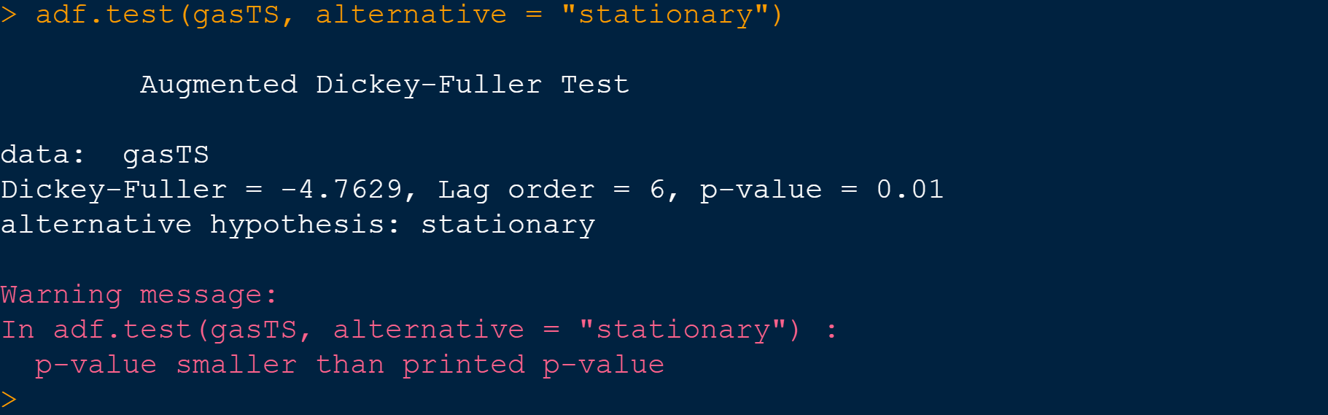

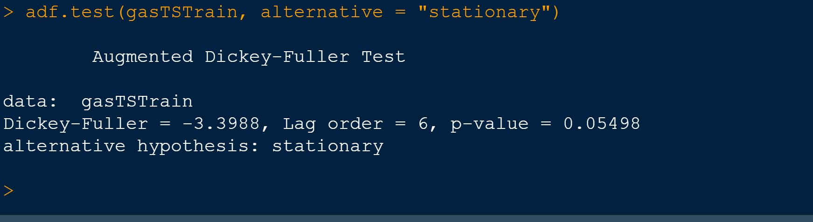
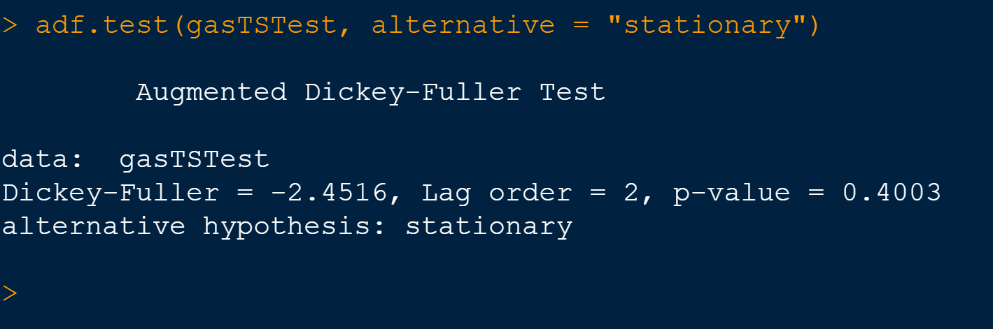

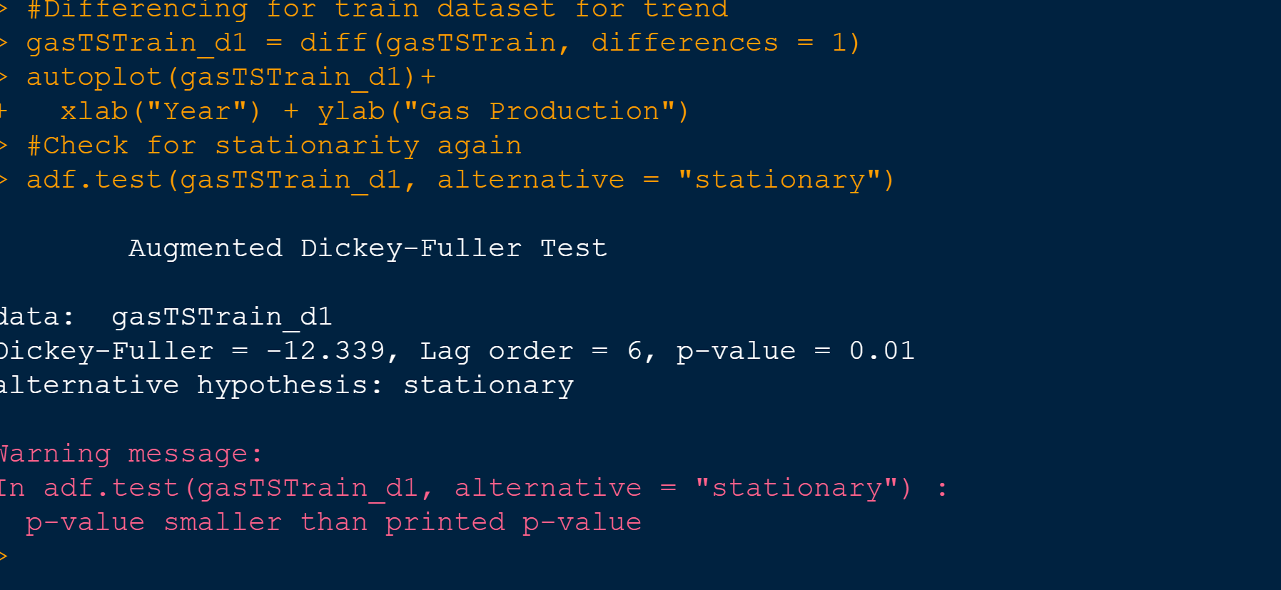

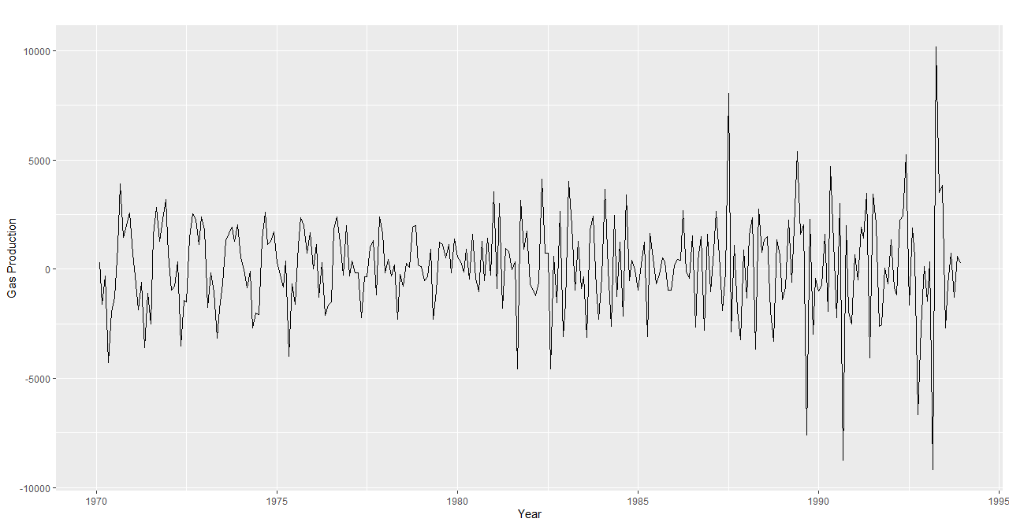

5. Develop an ARIMA Model to forecast for next 12 periods. Use both manual and auto.arima (Show & explain all the steps)

We will develop the ARIMA models using the auto.arima() function and manual methods as well. We will start with the auto arima and then see different manual models and finalize on the model.we will take the first order differencing of the time series to perform it.

For manual Arima we will perform the ACF & PACF auto correlation plots to figure out the correct values for P, d & q, which represent the Auto Regressive, Differencing and Moving Average components of the time series.

Auto Arima:
Here we will do it on the Train dataset with Seasonal=False and for illustration we will also try auto arima on original dataset (gasTS) with seasonal=True .

Lung’s Box plot : We will be doing a residual analysis for each model residuals using Lung’s method. The Null and Alternate hypothesis for the same are as below-

#H0: Residuals are independent
#Ha: Residuals are not independent

Observations:

- There are significant autocorrelations with many lags in our demand series, as shown by the ACF plot at intervals of 6 such as 6,12, 18 etc, so we can take q value as 6 since it is significant.

- PACF plot shows that there could be significance at lag 4 and yearly seasonality since the plot also peaks at intervals of 6. So we will go with p-value of 4.

- From the above observations,we will use a p,d,q combinations of (4,1,6) for manual models. Here d=1 because we ill be using the train dataset which need a first order differencing ( d=1)

- The model residual graph for the combination (4,1,6)gave almost the same results and visually the random components doesnt seem to have a dependency. However the auto arima gave a coombination of (4,1,1)
- All the Lung’s Box plot gave a p-Value of greater than 0.05 which indicates that the residuals were intependent, centered around 0 and normally distributed.
- The MAPE-value for the manual model was much better than the auto model for both train and test data sets.
- The AIC, AICc, BIC w=values were much better for the manual model compared to the auto model.
- The winner model was the manual one with p=4,d=1 & q=6. e got pretty good forecasts for th remaining 12 monthswith it.

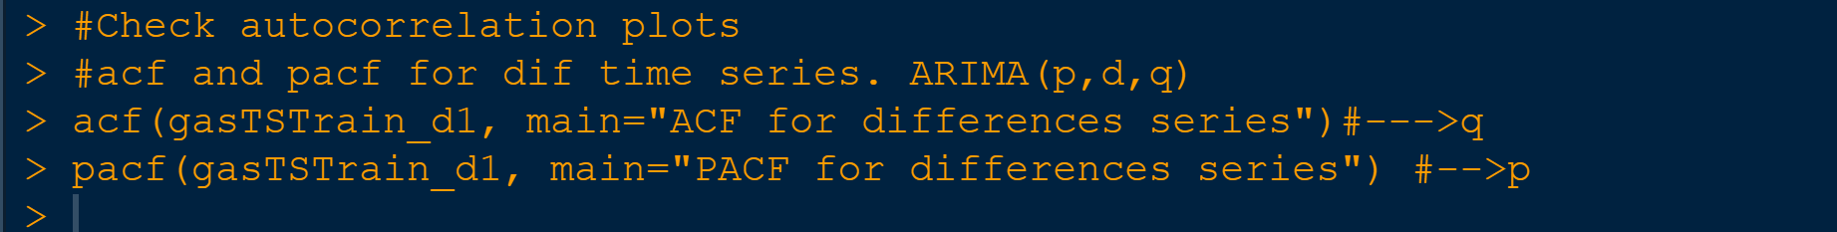

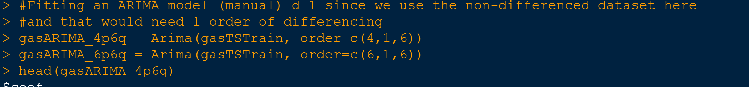

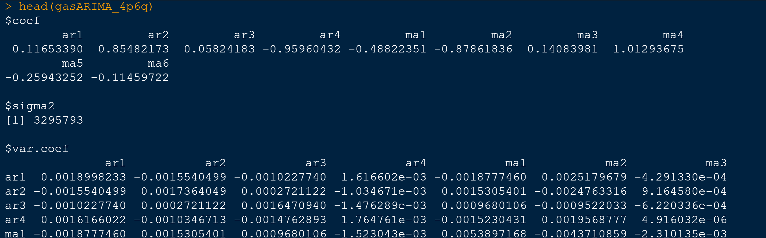

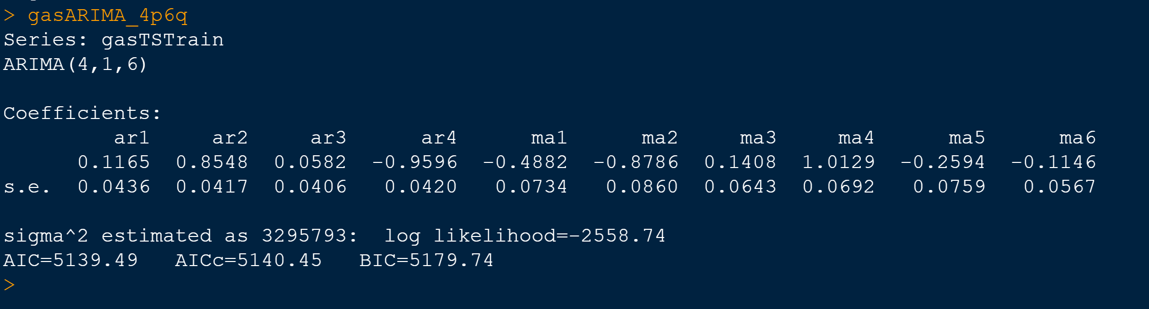

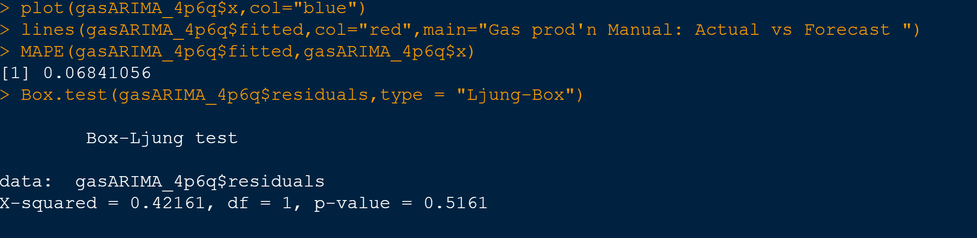

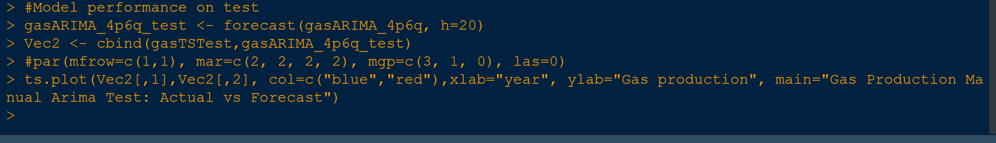

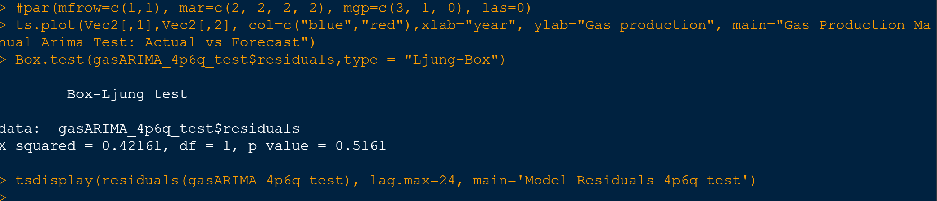

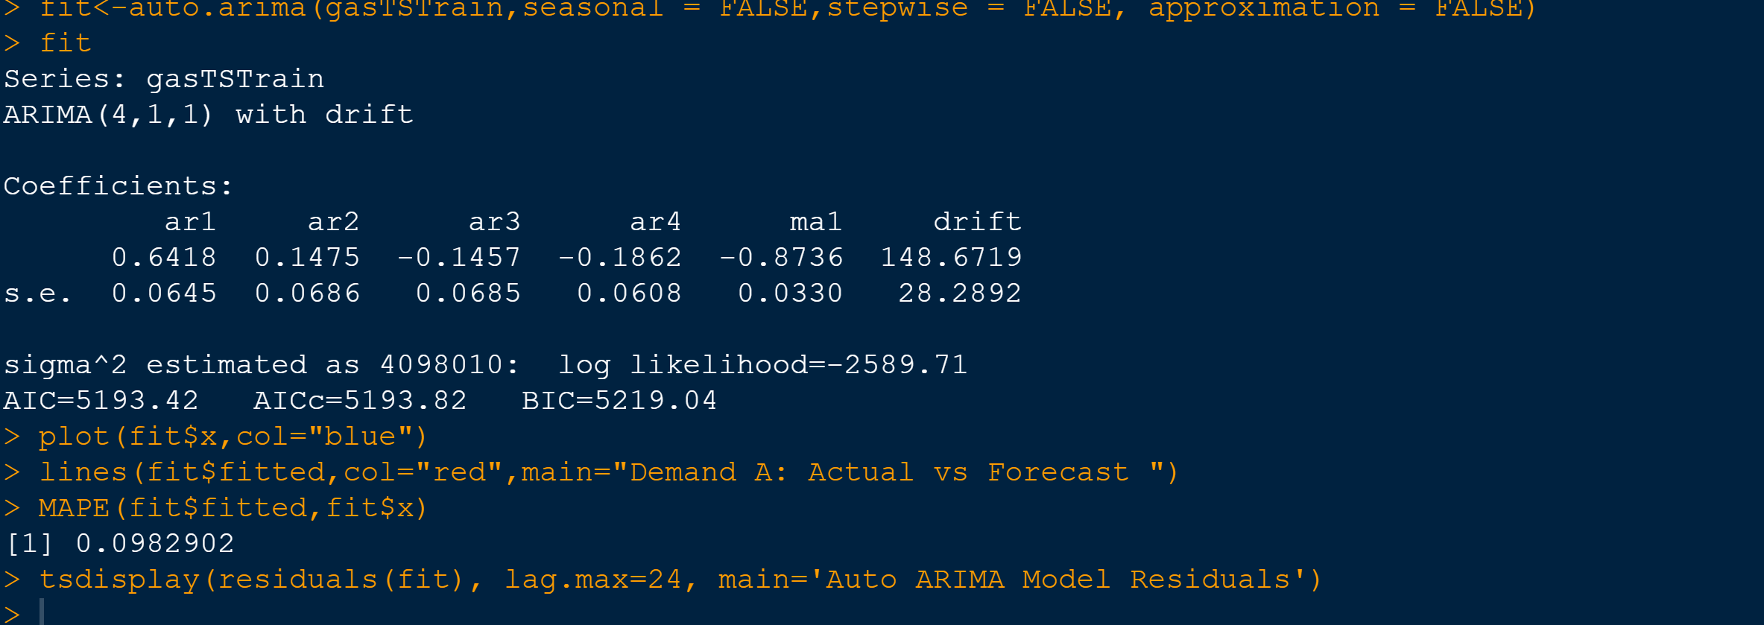

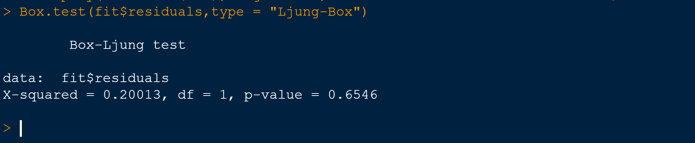

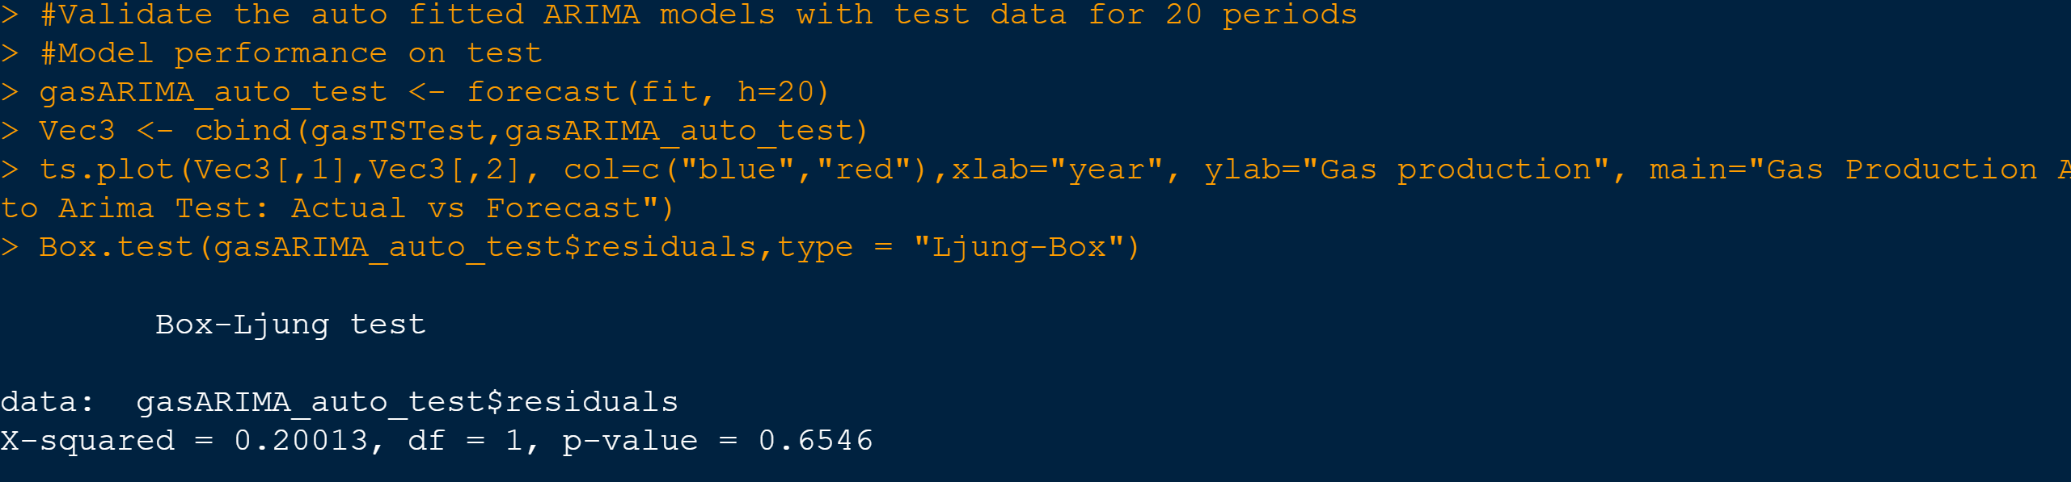
Accuracy Calculations:

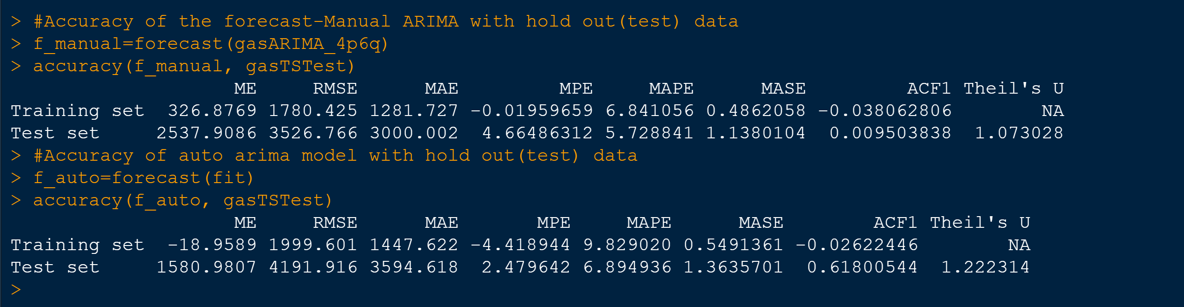

Best Model Forecasts for 12 months

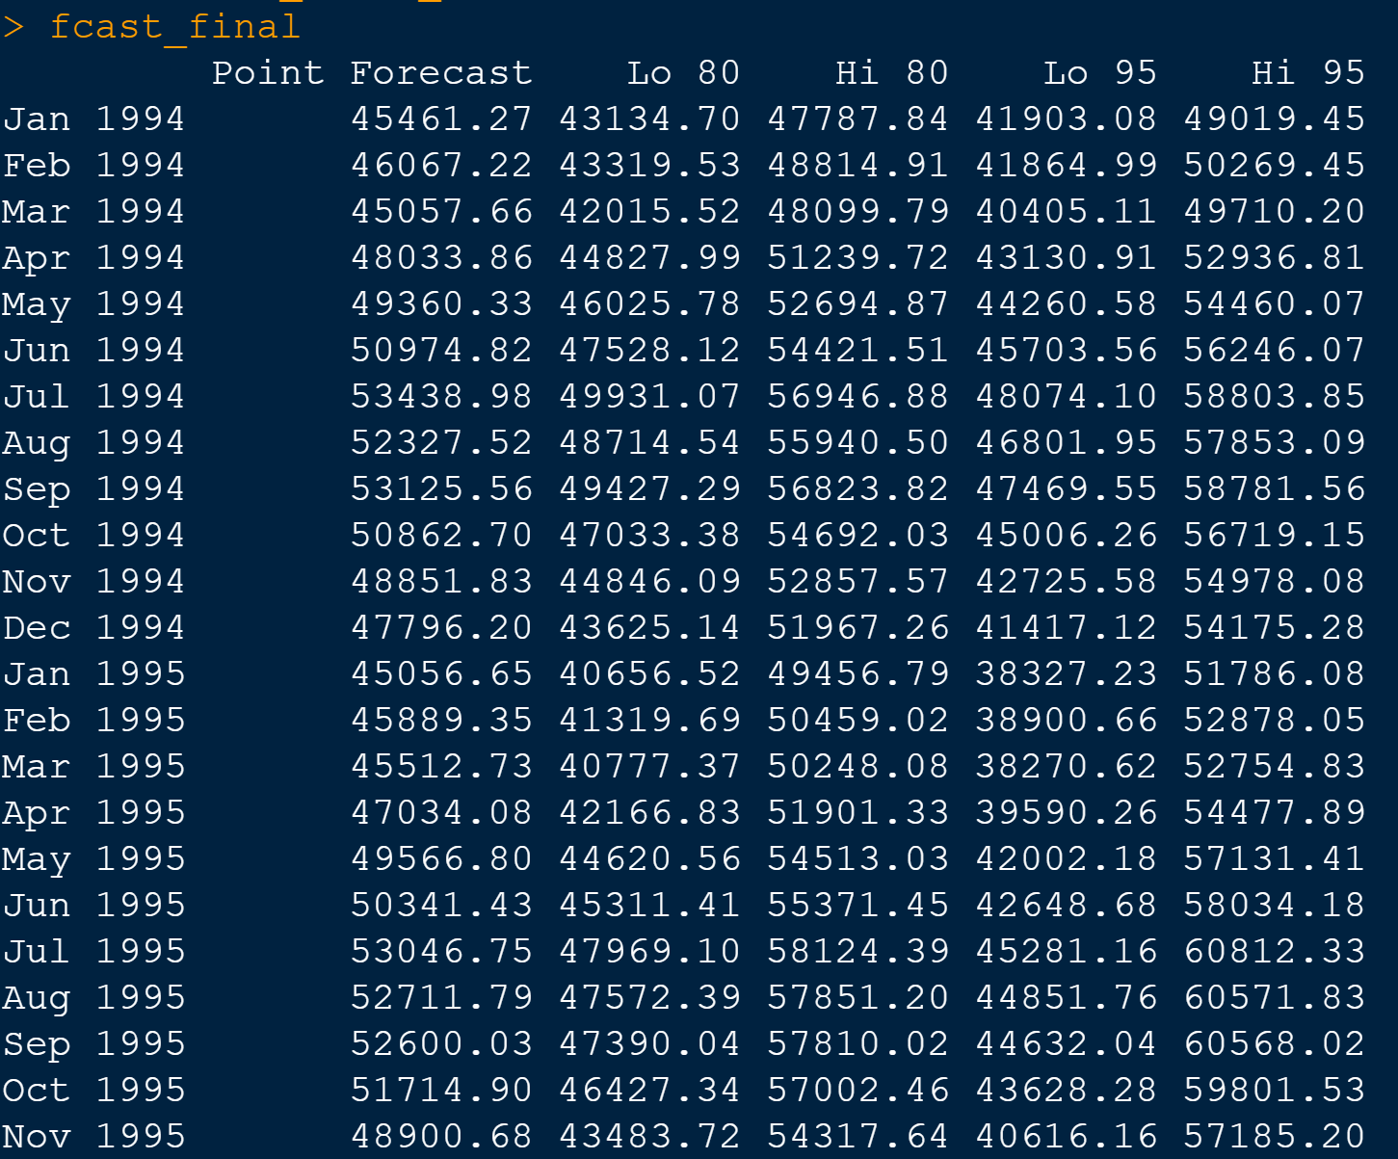
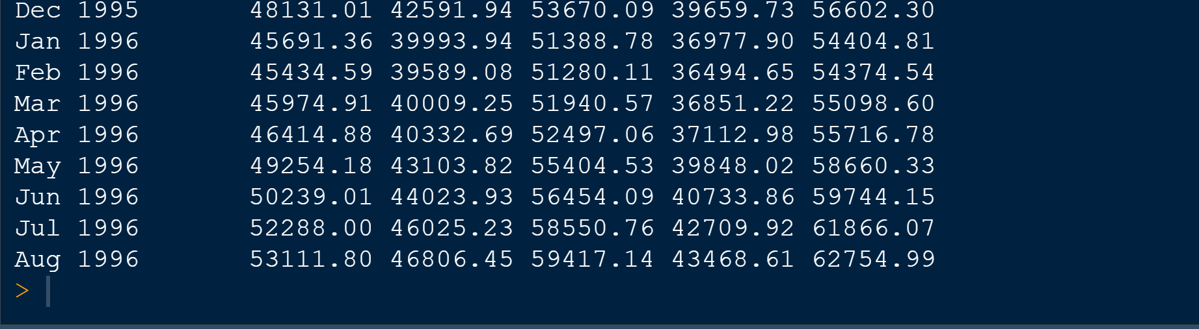

Plots:
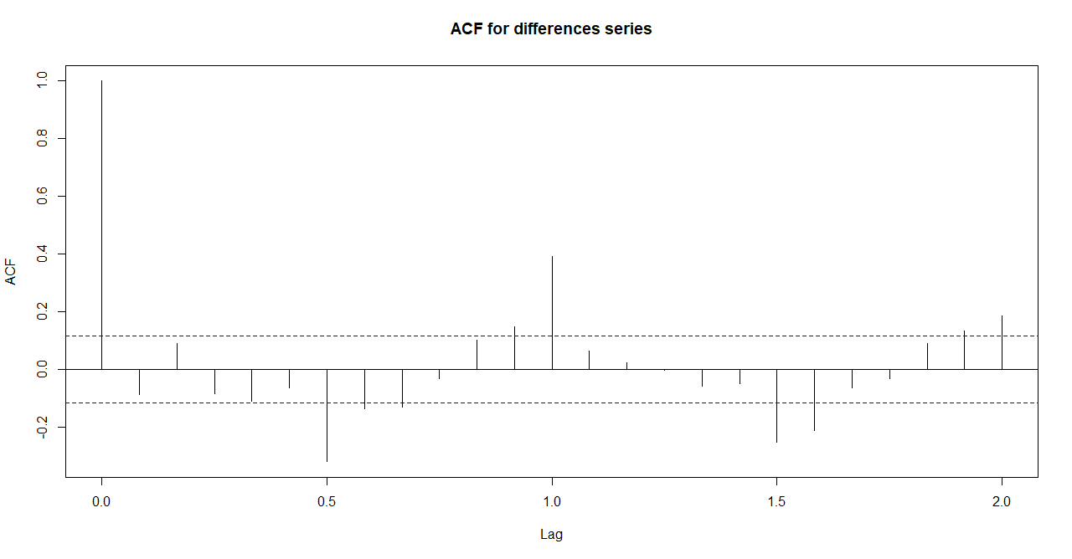
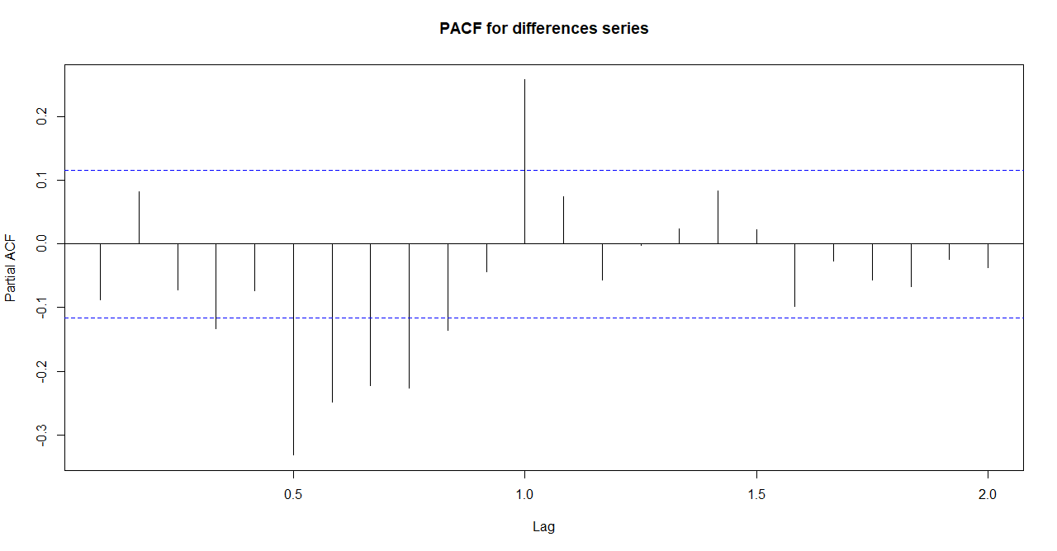

Manual model forecasts on train dataset vs actuals:
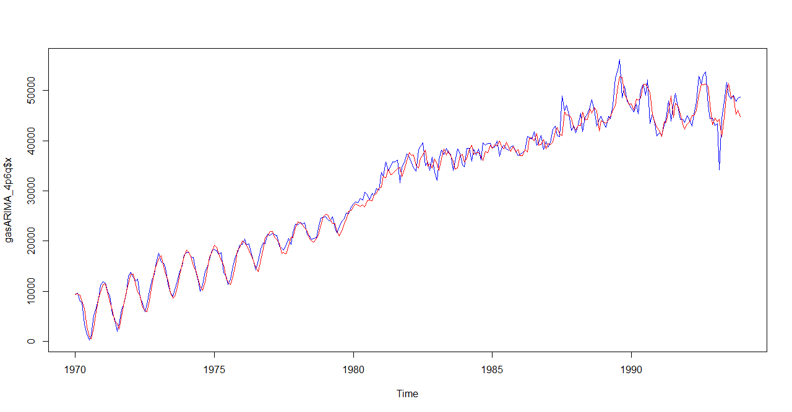
Manual Model residuals for train dataset
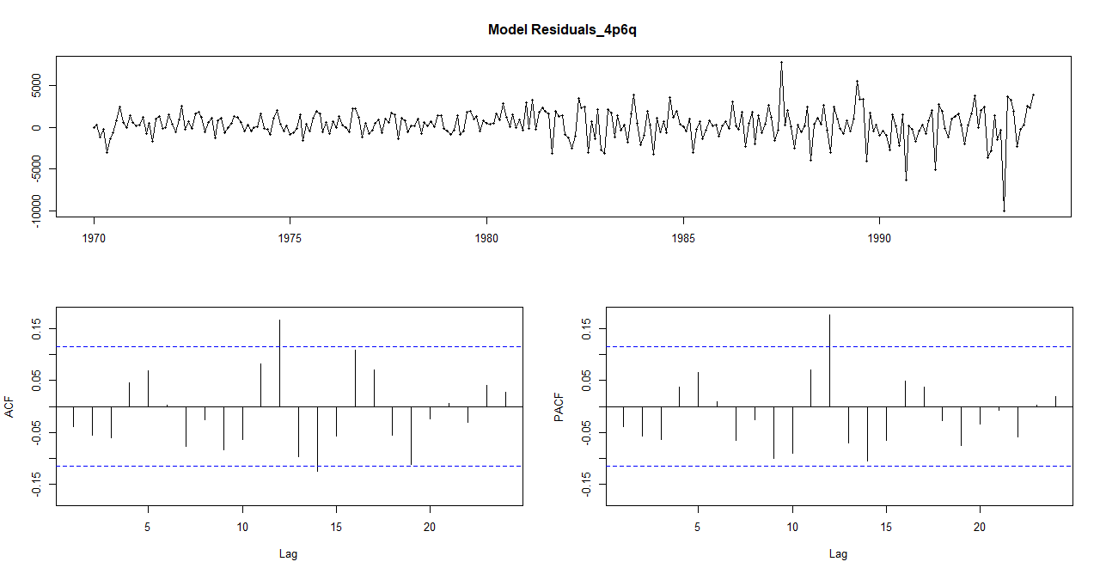

Auto model forecasts on train dataset vs actuals:

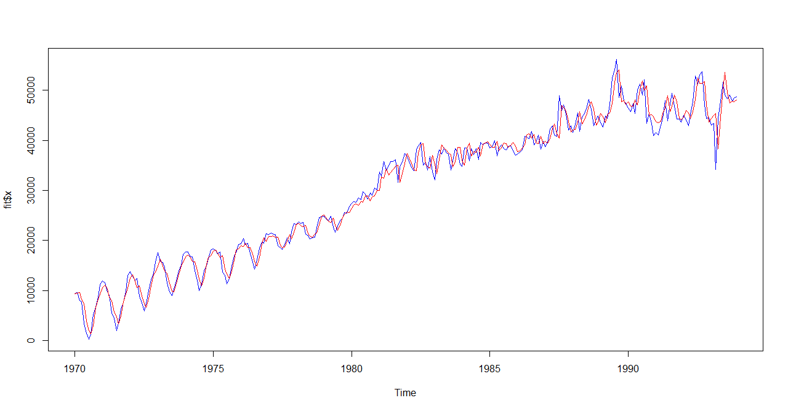

Autol Model residuals for train dataset

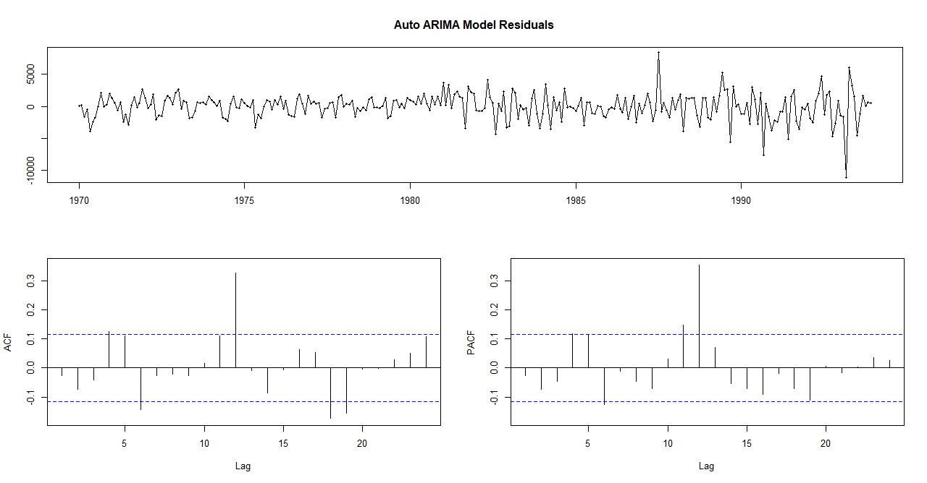

Manual model forecasts on test dataset:

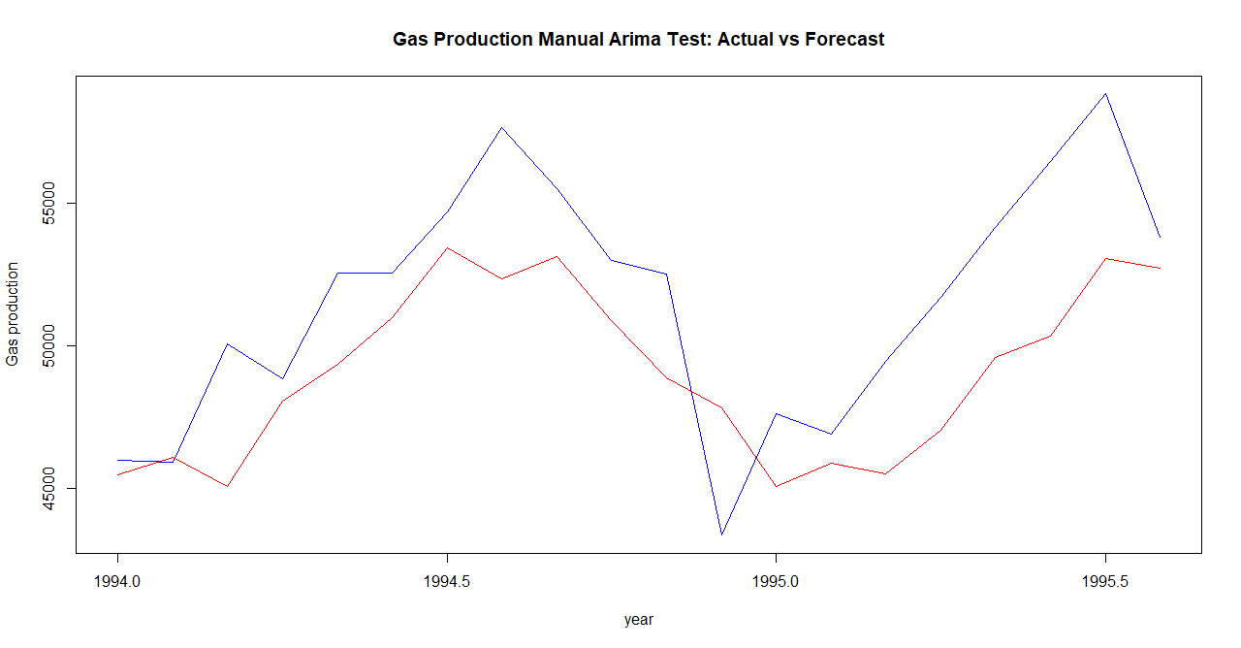

Manual Model residuals for test dataset
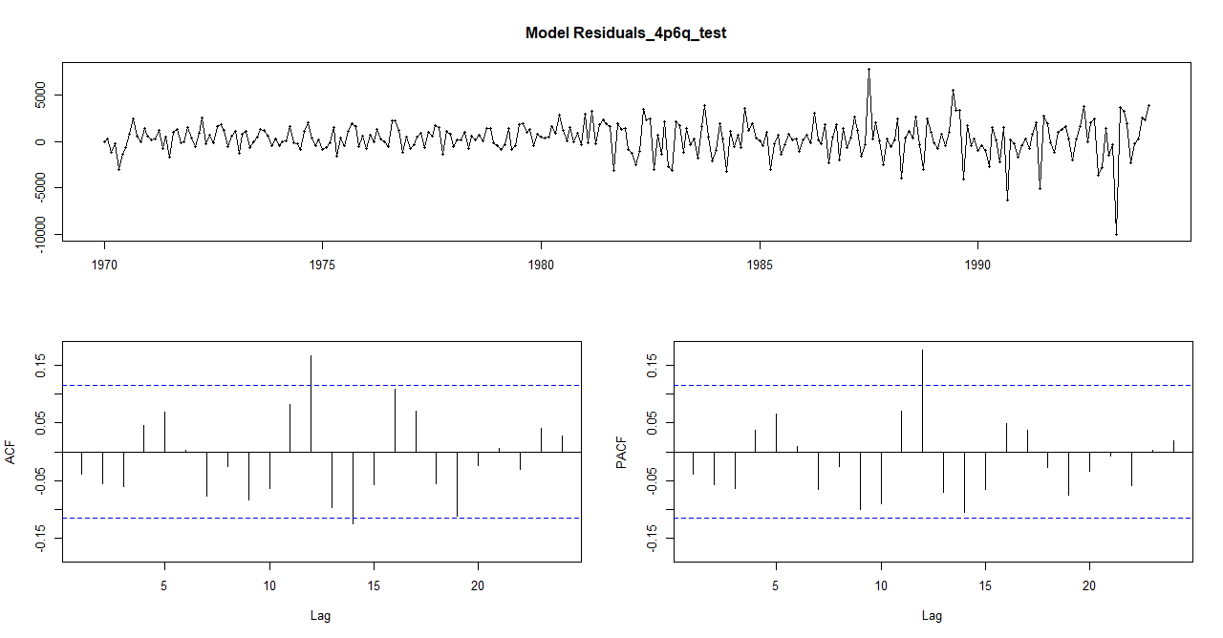

Auto model forecasts on test dataset:

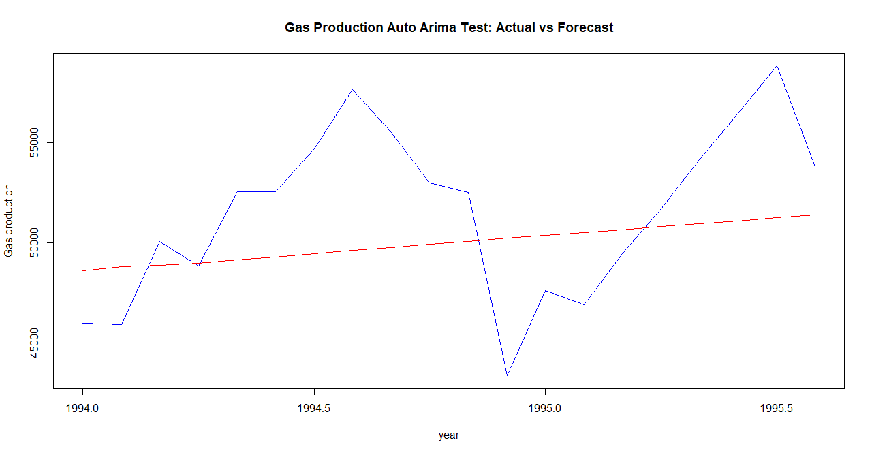

Autol Model residuals for test dataset

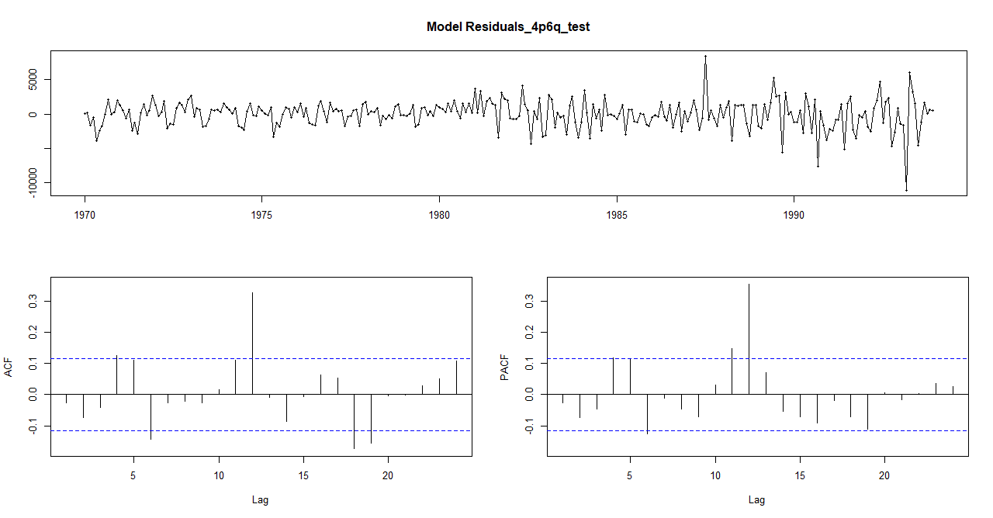

Auto Arima Forecast for final 12 months

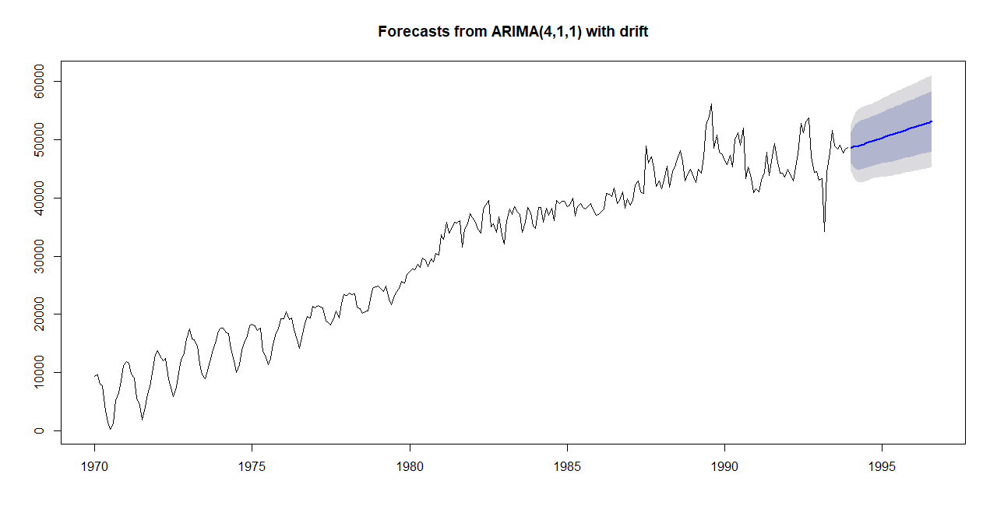

Manual Arima Forecast for final 12 months ( Finalized model)
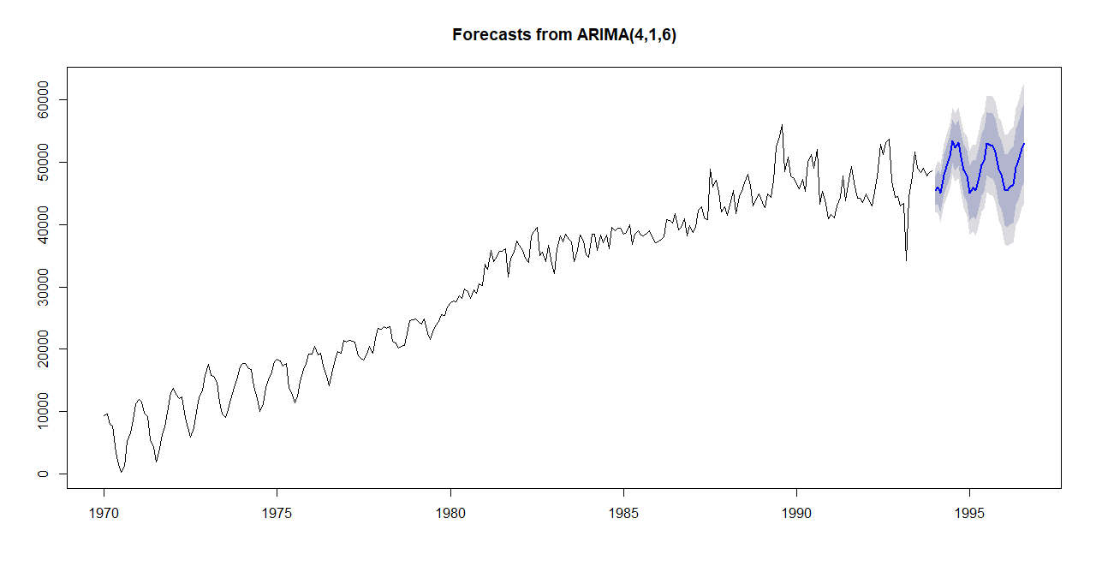

Report the accuracy of the model
We can clearly see that all the accuracy performance measures (MAPE, RMSE etc) are better for the manual model in comparison to the auto model for both train and test data sets. So we proceed with forecasts for the ARIMA manual model (4,1,6)

Appendix A:

######################################################################
########################### ARIMA GAS FOTRECASTING ########################
######################################################################
#Loading the required libraries
library('ggplot2')
library('forecast')
library('tseries')
library('MLmetrics')

#Setting the working directory
setwd("C:/2020/RProgramming/TimeSeries_Forecasting/")

data<- forecast::gas

dim(data)
class(data)
str(data)
summary(data)
head(data)
tail(data)
frequency(data)

#Checking for NA's
anyNA(data)

#Convert data to time series data and plot it
#Data is already a time series
autoplot(data) +
xlab("Year") + ylab("Aussie Gas production")

#Selecting the dataset only from 1970-Jan

gasTS <- window(data, start=c(1970,1), frequency=12)

#Plotting Again
autoplot(gasTS) +
xlab("Year") + ylab("Aussie Gas production")

# Plotting for monthplot and seasonplot & Boxplot
monthplot(gasTS, main = "Aussie Gas Production - Monthplot", xlab = "Month", ylab = "Count")

seasonplot(gasTS, year.labels = TRUE, year.labels.left=TRUE, col=1:40, pch=19, main = "Aussie Gas Production - Seasonplot", xlab = "Month", ylab = "Count")

cycle(gasTS)
boxplot(gasTS ~ cycle(gasTS), xlab = "Month", ylab = "Count", main = "Aussie Gas Production - Boxplot")

# Check for Seasonality & remove it ?
decom1 = decompose(gasTS,type="additive")
decom1$seasonal
plot(decom1)

decom2 = decompose(gasTS,type="multiplicative")
decom2$seasonal
plot(decom2)

# Using stl() function to desesaonalize
decom_stl <- stl(gasTS, s.window="p") #constant seasonality
plot(decom_stl)
decom_stl

#Adding the Trend & Reminder to deseanalise
series_names <- c('Deseasoned_Gas', 'Actual_Gas')
Deseason_gasTS <- (decom_stl$time.series[,2]+decom_stl$time.series[,3])
ts.plot(gasTS, Deseason_gasTS, col=c("red", "blue"), main="Actual Demand vs De-seasoned Gas Demand")

#Partitioning the dataset- We will use the dataset only from 1970-Jan
gasTSTrain <- window(Deseason_gasTS, start=c(1970,1), end=c(1993,12), frequency=12)
gasTSTest <- window(Deseason_gasTS, start=c(1994,1), frequency=12)

head(gasTSTrain)
head(gasTSTest)

#Check for stationarity using the Augmented Dickey-Fuller test on the train dataset

adf.test(gasTS, alternative = "stationary")
#Series is stationary since p-value is less than 0.05

adf.test(gasTSTrain, alternative = "stationary")
#Series is non-stationary since p-value is more than 0.05

adf.test(gasTSTest, alternative = "stationary")
#Series is non-stationary since p-value is more than 0.05

# Also using nsdiffs() to check if differencing is required
nsdiffs(gasTSTrain)

#Differencing for train dataset for trend
gasTSTrain_d1 = diff(gasTSTrain, differences = 1)
autoplot(gasTSTrain_d1)+
xlab("Year") + ylab("Gas Production")

#Check for stationarity again
adf.test(gasTSTrain_d1, alternative = "stationary")
#Differenced demand is stationary

########### Model Building ######################

#Check autocorrelation plots
#acf and pacf for dif time series. ARIMA(p,d,q)
acf(gasTSTrain_d1, main="ACF for differences series")#--->q
pacf(gasTSTrain_d1, main="PACF for differences series") #-->p

#There are significant autocorrelations with many lags in our demand series, as shown by
#the ACF plot at intervals of 6.

#PACF plot shows that there could be significance at lag 4 and yearly seasonality since
#the plot also peaks at #intervals of 6

#acf and pacf for dif time series. ARIMA(p,d,q)

#So here for manual we will use the combinations of pq as (4,6) & (6,6)

#Fitting an ARIMA model (manual) d=1 since we use the non-differenced dataset here
#and that would need 1 order of differencing
gasARIMA_4p6q = Arima(gasTSTrain, order=c(4,1,6))
gasARIMA_4p6q
head(gasARIMA_4p6q)

#gasARIMA_6p6q = Arima(gasTSTrain, order=c(6,1,6))
#head(gasARIMA_6p6q)
#Residual analysis using Ljung-Box test
#H0: Residuals are independent
#Ha: Residuals are not independent
#Check the residual analysis for both the manual arima and auto arima
library(stats)

# Plotting the train dataset actual Vs forecast using Arima-Manual
plot(gasARIMA_4p6q$x,col="blue")
lines(gasARIMA_4p6q$fitted,col="red",main="Gas prod'n Manual: Actual vs Forecast ")
MAPE(gasARIMA_4p6q$fitted,gasARIMA_4p6q$x)
Box.test(gasARIMA_4p6q$residuals,type = "Ljung-Box")
tsdisplay(residuals(gasARIMA_4p6q), lag.max=24, main='Model Residuals_4p6q')

#Validate the manually fitted ARIMA models with test data for 20 periods
#Model performance on test
gasARIMA_4p6q_test <- forecast(gasARIMA_4p6q, h=20)
Vec2 <- cbind(gasTSTest,gasARIMA_4p6q_test)
#Vec2
#par(mfrow=c(1,1), mar=c(2, 2, 2, 2), mgp=c(3, 1, 0), las=0)
ts.plot(Vec2[,1],Vec2[,2], col=c("blue","red"),xlab="year", ylab="Gas production", main="Gas Production Manual Arima Test: Actual vs Forecast")
Box.test(gasARIMA_4p6q_test$residuals,type = "Ljung-Box")
tsdisplay(residuals(gasARIMA_4p6q_test), lag.max=24, main='Model Residuals_4p6q_test')
MAPE(gasARIMA_4p6q_test$fitted,gasARIMA_4p6q_test$x)

#Fitting with Auto ARIMA.
nsdiffs(gasTSTrain)
fit<-auto.arima(gasTSTrain,seasonal = FALSE,stepwise = FALSE, approximation = FALSE)
fit
plot(fit$x,col="blue")
lines(fit$fitted,col="red",main="Demand A: Actual vs Forecast ")
MAPE(fit$fitted,fit$x)
Box.test(fit$residuals,type = "Ljung-Box")
tsdisplay(residuals(fit), lag.max=24, main='Auto ARIMA Model Residuals')

#Accuracy of the forecast-Manual ARIMA with hold out(test) data
f_manual=forecast(gasARIMA_4p6q)
accuracy(f_manual, gasTSTest)

#Accuracy of auto arima model with hold out(test) data
f_auto=forecast(fit)
accuracy(f_auto, gasTSTest)

#acf(fit$residuals)
#pacf(fit$residuals)

###############################
#Finalizing the model and doing predictions for next 12 months starting from Aug-1995.
#The best model was Manual model with p=4 and q=6
#Manual
fcast_final <- forecast(gasARIMA_4p6q, h=32)
plot(fcast_final)
fcast_final

#Auto
fcast_final_2 <- forecast(fit, h=32)
plot(fcast_final_2)

# We will go with the Manual Arima model.

